Long-Term Effects of Value-Driven Attentional Capture on Memory: Reward Influences Decision Processes but not Discriminability

Jonathan Yuquimpo

University of Illinois at Urbana-Champaign

Abstract

Value-driven attention capture (VDAC) is the process by which stimulus features associated with reward can involuntarily draw attention in contexts beyond the original one in which those associations were trained. Attention is a critical component of effective encoding into memory so it follows that VDAC may confer an advantage in remembering later stimuli that share those reward features. This study investigated whether participants trained to associate a color with probabilistically high or low reward amounts in one task would show improved memory for symbols presented in a previously rewarded color on a separate memory task in which color was irrelevant. In a learning phase, participants identified the orientation of a horizontal or vertical line positioned within a red or green circle. One color was paired with a higher reward contingency than the other color to imbue it with greater value. In a second task, participants viewed three sequential characters and made old/new judgments on a test character. Some lists contained a character that was presented in a previously rewarded color. We found no evidence that rewarded colors improved memory, but there was evidence suggesting that recognizers had a conservative response bias shift on lists with value-colored targets. This contrasts prior conclusions that reward improves memory speed and accuracy and instead emphasizes the need to consider whether reward may also affect memory decision processes.

*Keywords*: reward, attentional capture, visual working memory

Long-Term Effects of Value-Driven Attentional Capture on Memory: Reward Influences Decision Processes but not Discriminability

Reward is a powerful motivator that underlies many human behaviors and cognitive processes (Madan, 2017). One area in which reward has become increasingly relevant is attention. Attention has long been argued to be driven by a combination of top-down and bottom-up processes. Yet, a growing body of work has indicated that prior selection history, which includes selection driven by reward, is a third competitor involved in selective attention (Awh, Belopolsky & Theeuwes, 2012; Theeuwes, 2010; Theeuwes, 2018). Through a process called value-directed attentional capture (VDAC), learned stimulus-reward associations have been shown to automatically modulate attention such that reward-associated stimuli may receive greater attentional priority in spite of any current task-related goals of an observer (Anderson, Laurent & Yantis, 2011). Critically, VDAC may have unintended downstream effects on other related cognitive processes, including, in the case we pursue here, memory.

Value-driven attention capture was first identified by Anderson et al. (2011). Participants were trained using a visual search task to associate one of two target colors with a higher probability of receiving the greater of two reward amounts. Correct responses to a high-value colored target yielded an 80% chance of a high reward (5¢) and a 20% chance of a low reward (1¢), whereas this contingency was reversed for the low-value color. In a subsequent singleton detection task, the high- and low-rewarded colors from the training phase were presented as distractors. Trials with high-value distractors led to slower response times compared to trials with low-value distractors or distractors without any previously associated value. These results suggest that the magnitude of reward previously associated with a stimulus affected later unintentional attention capture, even when it was to the detriment of performance.

The effects of VDAC can persist from days to months after training (Anderson et al., 2013; Della Libera & Chelazzi, 2006, 2009) and is clearly evident in contexts in which the reward-associated stimuli are task-irrelevant or even counterproductive to an observer’s goals. In one such experiment by Le Pelley, Pearson, Griffiths and Beesley (2014), participants in a visual search task had had to direct their gaze towards a shape singleton while a colored distractor appeared elsewhere. The color of the distractor determined the amount of reward given in the trial but gazing towards that distractor would omit rewards for that trial. The authors found that high-value distractors captured oculomotor gaze more strongly than low-value distractors, and this finding was replicated even when participants were explicitly informed that they would lose points for gazing at the distractor (Le Pelley et al., (2014); Pearson, Donkin, Tran, Most & Le Pelley, 2015). It should be emphasized that throughout the task, the reward-associated stimulus was a to-be-ignored element, and thus remained task-irrelevant with no prior selection history to account for its attentional capture. This experiment illustrates just how automatically VDAC can occur, and how resistant it is to cognitive control.

Considering these powerful effects of reward on attention, a natural extension of the topic would be whether reward has similar effects on processes related to attention such as working memory. It is recognized that working memory shares common resources and is extensively involved with attention (Chun, 2011; Kyonaga & Egner, 2012; Chun & Turk-Browne, 2007). A particularly relevant function of attention includes selecting or prioritizing what information is maintained in working memory (Oberauer, 2019). Thus, the automatic biasing of attention towards rewarded stimuli may enhance memory of those items at the cost of reduced attention and memory capacity for unrewarded stimuli.

To this end, a number of studies have investigated whether reward influences visual working memory. In a study by Gong and Li (2014), participants completed a value-training procedure based on the visual search task used by Anderson et al., (2011). This was followed by a change blindness task that required participants to identify whether the orientation of one of eight uniquely colored lines in a visual search display changed in orientation after a 1000 – 2500 ms retention interval. Participants showed enhanced detection sensitivity, measured in *d’*, towards lines rendered in a high-value color compared to lines in a low-value colors or colors without value, but only after they completed the value-training procedure. To further illustrate that VDAC enhances memory capacity rather than just biasing spatial attention, the author conducted a follow up study where all lines in the search display were of the same color (i.e., all lines rendered in the high-value color, low-value color, or a no-value color). In such a display, participant cannot simply direct their attention towards the single high-value item, since all items are the same color. Yet, participants still showed superior memory for high-value-colored displays over low-value and no-value displays. This result provides evidence that reward may enhance memory in ways that cannot simply be accounted for by shifts in spatial attention.

Aside from memory enhancement, another study by Infanti, Hickey and Turatto (2015) revealed how reward may also have memory interference effects. In a similar memory task to Gong and Li (2014), participants were shown an array of eight circles, each with a horizontally or vertically oriented line. One circle, a colored singleton, could be presented in a high-, low- or no-value color learned from the same training procedure of Anderson et al., (2011). Participants then had to identify the orientation of the line in the probed location following a 50 or 800ms retention interval. The key assessment was whether the probe’s proximity to the color singleton would reduce accuracy. The authors found that interference was modulated by both the distance between the target and singleton, and the singleton’s color. Specifically, interference was present when the target was adjacent to the color singleton, but not when the target was one or more spaces away from the singleton. Furthermore, this interference effect was greater for high-value singletons compared to low-value and no-value singletons. Together, these studies demonstrate how reward can modulate attentional priority of stimuli in ways that lead to enhanced working memory of rewarded items at the cost of memory for other unrewarded items.

In explaining these findings, some have suggested that reward may act on visual working memory by enhancingvisual processing (O’Brien & Raymond, 2012; Itthipuripat, Vo, Sprague & Serences, 2019) or by increasing working memory capacity (Kawasaki &Yamaguchi, 2013). Others have suggested that reward shifts attentional allocation between items as a trade-off (Morey, Morey & Rouder, 2011). One such study by Sandry and Ricker (2020) investigated whether the orientation of attention towards a list item might increase maintenance of that item in visual working memory at the expense of other items. Participants were presented three sequential shapes. Most items were presented in black, but in some lists, one list item was presented in red. Participants were given a 2-alternative forced choice (2-AFC) recognition task where they had to identify which of two shapes was presented in the list. Furthermore, correct responses to black list items were worth 3 points (with a 3 point penalty for incorrect responses), but responses to red list items were worth 25 points (with a 25 point penalty for incorrect responses). Response times to reward-colored items were significantly shorter. Accuracy also followed a similar pattern, though to a lesser degree. This pattern was not evident however, when the reward contingency was changed so that red and black items were both worth 3 points. This led the authors to conclude that prioritized items were being better maintained in working memory in a way that cannot be accounted for by the distinctive color of the items.

The task used by Sandry and Ricker (2020) offers an intuitive way to measure several effects of rewarded stimuli against other non-rewarded items in a list. However, there are a few gaps left by the study. As with other studies in this domain, the possible effects of reward on response bias cannot be addressed due to the use of a 2-AFC task, since it only provides a measure of accuracy. As some have suggested, in a task where participants are given greater rewards for remembering some items over others, participants can voluntarily adopt different prioritization strategies (Bowen, Marchesi & Kensinger, 2020). Thus, we believe it would be a fruitful endeavor to substitute a 2-AFC task with an old/new recognition task where participants could make false alarms towards a rewarded list item. Furthermore, unlike prior studies that utilized separate training and test phases, participants in Sandry and Ricker’s (2020) experiment were rewarded in the memory task itself. Aside from directly encouraging alternate rehearsal strategies as previously mentioned, this also limits any interpretations about the extent to which learned reward associations in one task unintentionally transfer to another task.

The aim of the current study was to more precisely examine the impact of reward processing on involuntary aspects of working memory with combined analyses of response time, discriminability, and response bias. We used the value-learning procedure of Anderson et al. (2011), followed by a visual working memory task based on the task used by Sandry and Ricker (2020). In the learning phase, two reward amounts (high and low) were associated with two target colors (red and green). In the transfer phase, participants were presented with a series of three symbols followed by a test probe that asked whether the probed item was a new or old item. In some lists, one item was presented in a high- or low-value color. In “old” lists with a colored item, the probe could be for the value-colored item, or it could be for a non-colored item. This experiment expands on Sandry and Ricker’s (2020) study in a few ways. By ensuring that rewards are only delivered in a previous training phase and not in the test phase, we ensure compatibility between our findings and those of VDAC literature. Furthermore, by using an old/new judgement task, we can separate the effects of reward on discriminability and criterion placement, both for rewarded items and for unrewarded items in proximity to a rewarded item.

We propose two hypotheses. First, if reward enhances attention in a way that boosts working memory representation, we expect to see faster response times and/or greater discriminability for items rendered in a high reward color. Alternatively, if reward-association does not boost memory, but instead simply leads to strategic shifts in response bias towards rewarded items, we expect to see a shift in response bias. Based on a study by Bowen et al. (2020), who found that increasing reward magnitude for a category of test items led to a liberal criterion shift (more willingness to endorse an item as old) for items of that category, we predict a similar relation between reward magnitude and response bias.

**Methods**

**Participants**

Seventy students from the University of Illinois at Urbana-Champaign participated in the online study in exchange for course credit. Data from sixty-two students (46 female, 16 male) were used in this analysis. Data from 10 students were excluded (1 due to data collection issues; 3 due to incomplete cell counts for our ANOVA analysis; 4 due to having performed below 2 standard deviations of the group means in either the training phase or transfer phase). We selected our sample size according to the lower bound of effect sizes found from a similar study by Sandry, Schwark, and MacDonald (2014) (Cohen’s *d* = 0.3). We estimated needing 70 participants for a within-samples design to achieve a (1 – beta) level of 0.8 at an alpha level of 0.05. We advertised 70 participation slots and collected responses until the cutoff. All participants had normal or corrected-to-normal vision and normal color vision.

**Materials**

The study was run online on a university server. Stimuli were created with the JsPsych 6.2.0 library in Javascript (de Leeuw, 2015). While we could not control for individual screen differences, participants with a monitor resolution below 480p x 480p were excluded from running the experiment.

**Procedure**

The experiment took about an hour to complete and was comprised of two parts.

***Training Phase***

In the training phase, participants completed a visual search task in which they identified the orientation of a horizontal or vertical bar positioned within a green or red target circle. Each trial began with a fixation cross lasting between 400 to 600 ms. The search display was presented for 1000 ms or until participant response and consisted of 6 black lines each contained within a uniquely colored circle. The stimuli were arranged in an equidistant circle around the fixation cross, as shown in Figure 1. Five of the six lines were randomly orientated in a diagonal direction (+45° or -45°) and each was encompassed by a non-target colored circle (cyan, blue-violet, black, magenta, and gold; colors are reported according to html color names). The target line was oriented either horizontally or vertically and was defined by a green or red circle; only one target was presented in each trial. The target was equally likely to appear in any of the six positions. Participants were instructed to search for a red or green target circle and to report as quickly and as accurately as possible the orientation of the line inside the circle by pressing “Z” for horizontal or “M” for vertical. After the search display was presented, participants received feedback using a point display for 1500 ms. Participants received “+2 points” or “+10 points” for correct responses and “Miss” for wrong or late responses along with a running total of how many points they had earned thus far in the experiment.

For each participant, one of the two target colors (red and green) was randomly assigned as the high-value color, and the other as the low-value color. Correct responses to high-value targets had an 80% chance of receiving a higher reward amount of 10 points and a 20% chance of receiving a lower reward amount of 2 points, with the opposite assignment for low-value targets. Thus, the training phase imbued one color with a (probabilistically) high value and the other color with low value.

Participants completed 10 practice trials with the option to repeat those trials before moving to the experimental trials. Participants completed 200 experimental trials divided in 4 blocks. Between blocks, participants were given a 30-second break screen that reported overall accuracy and the total number of points they have earned.

***Transfer Phase***

The test used a rapid serial visual presentation (RSVP) procedure, with each list followed by a yes-no recognition trial. Each trial began with a fixation cross lasting between 400 to 600 ms. Then, three different symbols were sequentially presented for 500 ms each followed by a 500 ms mask, as shown in Figure 2. We used a set of 90 unique symbols taken from the Brussels Artificial Character Sets (Vidal, Content, & Chetail, 2017), which are a set of standardized characters that emulate features of various languages without being identifiable to participants. Within each trial, characters were randomly sampled without replacement from the total stimulus set, but symbols could be repeated between trials. Symbols were mostly presented in black but, on some trials, one character was presented in red or green. We refer to these items as high-value items and low-value items, corresponding to their reward association from the training phase, but it should be noted that participants did not receive any rewards in this phase, so the value color had no bearing on the task. Participants were then shown a test item with a prompt to identify the item as old, meaning it was previously shown in the list, or new, meaning it was not shown in the list. Test items were always displayed in black regardless of whether the item was rendered in color during its initial presentation.

To maximize the number of critical trials, we adjusted the number of old vs. new trials and the number of colored to non-colored trials. There were 120 old trials and 80 new trials. Of the new trials, 20 lists had no color, 30 had the high-reward color (10 for each of the three serial positions) and 30 had the low-reward color. For the old trials, 30 had no color, 45 had the high-reward color (15 in each of the three serial positions) and 45 had the low-reward color. For each condition, old targets were equally distributed in across the three serial positions.

After the three to-be-remembered items were presented, a test item was presented for 2500 ms or until participant response. Participants were prompted to press “Z” if the test item was an old item previously presented in the list or “M” if the test item was a new item that was not presented in the list. After each response, feedback was displayed for 1500 ms with “Correct” for correct responses or “Miss” for wrong or late responses. However, unlike the training phase, participants did not receive any points. The color of list items was no longer relevant in this phase.

Participants completed 10 practice trials with the option to repeat those trials before moving to the experimental trials. Participants completed 200 experimental trials divided in 4 blocks. Between blocks, participants were given a 30-second break screen that reported overall accuracy.

**Results**

We used *t*-tests and ANOVA tests as our primary means of analysis but supplemented these measures using Bayes factor tests. The Bayes factors presented here represent the ratio of the probability of our data given an effect is present to the probability of our data given an effect is not present. For example, a Bayes factor of 10 would be interpreted as the alternative hypotheses being 10 times more likely than the null hypotheses given the data. Conversely, a Bayes factor of 0.10 would be interpreted as the null hypotheses being 10 more likely than the alternative hypothesis given the data. Analyses were calculated using BayesFactor version 0.9.12-4.2 in R with default settings.

***Learning Phase***

Mean response time to high- and low-value targets did not differ significantly, though participants tended to respond slightly faster to high-value targets than low-value targets [mean difference = 4.2 ms, *t*(61) = 1.202, *p* = .234, BF = 0.275]. To examine the effect of reward as participants progressed through training, we binned the data in four bins of 50 trials. There was a main effect of trial block [*F*(3, 488) = 12.535, p < .001, BF = 1.67×10­19] but no interaction between reward and trial block [*F*(3, 488) = 0.307, p < .820, BF = 1.17×10­17]. This suggests that although participants responded faster with more training, reward had no detectable effect. Response times by reward condition and trial block are presented in Figure 3.

We applied the same analyses to accuracy (in proportion correct). Mean accuracy to high- and low-reward targets did not differ significantly [mean difference = 0.0023 proportion correct, *t*(61) = 0.081, *p* = .935, BF = 0.139]. We again binned the data in four blocks of 50 trials each. There was a main effect of trial block [*F*(3, 488) = 9.782, p < .001, BF = 1.44×10­9] but no interaction between reward and trial block [*F*(3, 488) = 0.736, p =.531, BF = 1.17×10­17. Again, this suggests that while there was an effect of practice on accuracy, there was no effect of reward or any interaction between practice and reward. Accuracy by reward condition and trial block are presented in Figure 3.

***Transfer Phase***

Our primary interest was whether reward associations from the learning phase would transfer over and affect performance on a visual working memory test. We measured performance using a signal detection theory framework (Green & Swets, 1996) including discriminability (*d’*), criterion placement (c), and supplemented these measures with response time. All *d'* values were edge corrected for extreme values (*d’* of 0 or 1) using Macmillan and Kaplan’s (1985) 1/(2N) rule for proportions.

To examine the overall effect of reward on performance, we collapsed responses into three groups corresponding to the reward condition (high, low, and control). For each participant, we calculated the number of hits, the median response time that participants made across lists in which the test item was the value-colored item for each given reward condition (e.g., a list where the test item and the reward-colored item was in the first serial position). This was compared to the control condition which had no colored item. We counted our false alarm rate according to the number of “old” responses towards lists containing a value-colored item or no colored item where the prompted item was a new item. Therefore, in a list where the value-colored item was the first item, participants could produce a hit if the prompt contained an old item or participants could produce a corresponding false alarm if the prompt contained a new item.

Means for collapsed hit rate, false alarm rate, response times, and calculated *d’* and c values are shown in Figure 4. One-way (color value: high vs. low vs. control) repeated measures ANOVAs were performed on each performance measure. No significant difference was found between value conditions for hit rate [*F*(2, 122) = 0.718, p = . 490, BF = 0.1006], false alarm rate, [*F*(2, 122) = 2.600, p = .078, BF = 0.5093], discriminability [*F*(2,122)= 0.402, p = .670, BF = 0.0790], criterion, [*F*(2,122 ) = 1.784, p = .172, BF = 0.2610], and response time [*F*(2, 122) = 0.129, p = .971, BF = 0.0618]. Summary of comparisons are shown in Table 1.

We additionally performed planned comparisons between high- and low-value lists. This analysis compares whether the magnitude of reward changes how participants respond to an item. This is necessary since a simple reward vs. control comparison may be confounded by valued items having a unique color. A summary of comparisons is presented in Table 2. No significant difference was found between high- and low-reward conditions for hit rate [*t*(61) = -0.104, p = .916, BF = 0.1398], false alarm rate, [*t*(61) = -1.618, p = .110, BF = 0.4762], discriminability [*t*(61) = 0.289, p = .773, BF = 0.1447], criterion, [*t*(61) = 0.896, p = .338, BF = 0.1994], and response time [*t*(61) = -0.379, p = .705, BF = 0.1489].

Next, we analyzed the effect of reward according to individual serial positions. Performance measures according to the position of the target and the position of colored list item are shown in Figure 5. For our analysis we compared performance to test items in serial position 1, 2, and 3 (corresponding to the first, medial, and last position) across the three value-conditions. To illustrate, for lists where the target item is in the first serial position, we compared responses to that list with a high-value item, a low-value item, and the control list. A summary of comparisons can be found in Table 3. We found no significant differences in response time across the three value conditions for all three serial positions. The most notable findings are for discriminability and criterion. We found a significant difference in discriminability between reward conditions for serial position 3 [*F*(2, 122) = 4.514, p = .0128, BF = 2.583], but not for serial positions 1 and 2. Furthermore, we found significant differences in response bias for all serial positions, with traditional null-hypothesis tests and Bayes Factors in agreement on two of three serial positions: serial position 1 [*F*(2, 122) =3.317, p = .039, BF = 1.04], position 2 [*F*(2, 122) = 4.58, p = .012, BF = 3.11], and position 3 [*F*(2, 122) =7.184, p = .001, BF = 26.5].

We performed additional planned pairwise *t*-test comparisons between high-value, low-value, and control lists. A summary of comparisons is presented in Table 4. Significant differences were found between high-value and the control lists for discriminability and criterion. For discriminability, we found differences for serial position 3 [*t*(61) = -2.006, p = .0492, BF = .9041], but no other serial positions. With such a low Bayes Factor value however, this finding should be taken with caution. Stronger evidence of an effect was found for criterion. There were significant differences between high-value and control lists for serial position 1 [*t*(61) = 2.64, p = .010, BF = 3.347], position 2 [*t*(61) = 3.33, p = .001, BF = 18.79], and position 3 [*t*(61) = 3.90, p < .010, BF = 96.04]. No other significant differences were found between high-value and low-value list comparisons.

Lastly, we performed pairwise analyses on lists where a non-colored target item was presented alongside a value-colored non-target item. The purpose of this analysis is to examine whether value-colored items can interfere with memory for non-colored items when situated adjacently to the target (colored item in position 2; target item in position 3) or one position away in the list (colored item in position 1; target item in position 3). A summary of comparisons is presented in Table 5. We found no significant differences in our comparisons for response time and discriminability. However, our analysis of response bias revealed differing effects of the colored item position on criterion. When the colored item was one position away, there was a significant difference in criterion between the high-value and control lists [*t*(61) = 3.726, p < .001, BF = 57.13] but not between the high-value and low-value lists [*t*(61) = -1.167, p < .247, BF = 0.265]. Furthermore, the low-value condition had a more conservative response bias compared to the high-value condition which contrasts the previous pattern of higher criterion for higher reward conditions. On the other hand, when the colored item was adjacent to the target item, there were significant differences between high-value and control lists [*t*(61) =4.741, p < .001, BF = 1403] as well as between high- and low-value lists [*t*(61) = 2.476, p = .016 , BF = 2.301]. These differences follow the general pattern of more conservative criterion shifts towards higher value conditions.

**General Discussion**

Our present study examined whether reward-associated stimulus features could affect visual working memory performance in a task where previously learned reward-associations are no longer relevant. In our experiment, we trained participants to associate two target colors (green and red) with higher or lower value using a visual search task based on Anderson et al., (2011). In a subsequent visual working memory tasked adapted from Sandry and Ricker (2020), we presented participants with a list of three symbols and asked them to make old-new judgements on a test item. Crucially, some lists included a symbol that was rendered in a high- or low-value color even though participants did not receive any reward in the memory task. We predicted that participants would have enhanced memory of list items rendered in the high-value color compared to the low-value color or no color at all. Results from our experiment failed to provide strong evidence that reward-associated stimulus features enhance discriminability or response time, but our study revealed an unexpected effect of reward on response bias.

In general, we found no overall difference in discriminability between reward conditions except when we examined items by individual serial position. Unexpectedly, we found significantly higher *d’* in serial position 3 for the control lists than in the high-value lists. It should be noted however, that a discrepancy exists between higher observed *d’* for the control condition when examining individual serial positions versus the lower *d’* for the control condition when examining collapsed conditions. As we will discuss in detail later, this may be an artifact of our low cell counts causing more edge correction cases in the uncollapsed analysis.

Likewise, we found no effect of reward on response time. Neither our collapsed or uncollapsed analysis revealed any significant trends. This null result stands in contrast to Sandry and Ricker (2020), who found clear effects of reward on response time.

More convincing results were found for response bias. Our collapsed analysis reveals a clear trend where participants responded more conservatively (i.e., less likely to respond with “old”) for lists with a high-value item. In our uncollapsed analysis, this trend was also evident by serial position. Across all three item positions, responses to high-value lists were generally more conservative compared to low-value and control lists. Furthermore, when analyzing response bias for non-colored targets in the presence of a value-colored non-target item, we found that the proximity of the value-colored item also affected response bias. A significant difference in response bias between high- and low-value conditions was found when the colored item was adjacent to the target but not when it was one position away from the target. This concurs with other studies showing that the proximity of a rewarded distractor to a to-be-remembered item affects accuracy and response time (Infanti, et al., 2015; Sandry, Schwark & MacDonald, 2014).

These results provide novel insights into how value-driven attentional capture may interact with related processes like memory. Although previous studies (Gong & Li, 2014) have suggested that reward enhances memory without significant changes to response bias, our results instead show stronger effects of reward on response bias than on discriminability, which is in line with the conclusions made by Bowen et al. (2020). However, unlike Bowen et al., (2020), who found that high-value items led to a liberal shift in response bias, we instead found that high-value items led to a conservative shift. While our study does not offer enough information to make any definitive conclusions about this discrepancy, it should be noted that participants in Bowen et al.’s (2020) experiment were explicitly informed that they would be rewarded according to the category of the to-be-remembered item; hence, participants may have intentionally adopted a more liberal strategy towards rewarded categories as a means of optimizing their gains. Likewise, Sandry and Ricker’s (2020) study also rewarded participants according to the color of the to-be-remembered item, so participants could voluntarily allocate more of their attention towards high-reward items to maximize the rewards they gained. By contrast, our study focuses on the highly automatic and generalizable nature of VDAC by demonstrating how reward-associations learned in one task may impact memory in a different task where any reward associations are task-irrelevant. Thus, the change in response bias we found in our memory task may be the result of an automatic carryover effect from the previous learning task. Replicating and explaining why participants adopted a conservative shift towards higher-value lists will need further study.

While our current paradigm offers new insights into understanding reward and memory interactions, there are several limitations that ought to be acknowledged. Firstly, we limited the number of training trials across the learning and transfer phases compared to similar experiments to fit accommodate limited time constraints. This has two consequences for our study. Reducing the number of learning trials to 200 trials may have been insufficient to ensure carryover of effects across such different tasks. While experiments by Anderson et al. (2011) demonstrated VDAC transfer between similar attention tasks in as few as 240 trials, our study employs vastly different stimuli between our attention and memory tasks, which may demand additional training for successful transfer. Furthermore, limiting the number of working memory trials also causes issues with edge corrected *d’* prime calculations for our uncollapsed analysis as there were only five critical trials for each combination of color and target position. Participants with a hit rate of 1 over the five value-colored trials for a given target position had performance scores reduced to accommodate *d’* calculation. For the control group, which had cell counts of 10 for each target position, this was less of an issue. Though collapsing our data alleviates some of these issues, adopting non-parametric measures or increasing trials counts would provide more consistent outcomes. Furthermore, with sufficient trials counts, it would also be possible to use more robust response time measures such as drift-diffusion modeling to better understand if reward may have affected response time distributions in ways that are not as well characterized by a simple median.

In conclusion, our study has shown that reward-associated stimulus features can impact memory performance in ways that shift response independently of discriminability. We found that items associated with greater magnitudes of reward lead to an unexpected conservative shift in response bias. This shift occurs despite the fact that the reward-associations are irrelevant to our memory task. However, we failed to find substantial effects of reward response time and discriminability in contrast to other studies. While much of the literature has explored how reward impacts memory performance, fewer have explored whether reward may interact with memory decisions like response bias as we have discussed here. The present study offers a new perspective using familiar paradigms to explore the integrated effects of reward on response time, discriminability, and response bias.

References

Anderson, B. A., & Yantis, S. (2013). Persistence of value-driven attentional capture. *Journal of experimental psychology. Human perception and performance*, *39*(1), 6–9. <https://doi.org/10.1037/a0030860>

Anderson, B. A., Laurent, P. A., & Yantis, S. (2011). Learned value magnifies salience-based attentional capture. PLoS ONE, 6(11). <https://doi.org/10.1371/journal.pone.0027926>

Awh, E., Belopolsky, A. V., & Theeuwes, J. (2012). Top-down versus bottom-up attentional control: a failed theoretical dichotomy. *Trends in cognitive sciences*, *16*(8), 437–443. <https://doi.org/10.1016/j.tics.2012.06.010>

Bowen, H. J., Marchesi, M. L., & Kensinger, E. A. (2020). Reward motivation influences response bias on a recognition memory task. *Cognition*, *203*(June), 104337. <https://doi.org/10.1016/j.cognition.2020.104337>

Chun M. M. (2011). Visual working memory as visual attention sustained internally over time. *Neuropsychologia*, *49*(6), 1407–1409. <https://doi.org/10.1016/j.neuropsychologia.2011.01.029>

Chun, M. M., & Turk-Browne, N. B. (2007). Interactions between attention and memory. *Current opinion in neurobiology*, *17*(2), 177–184. <https://doi.org/10.1016/j.conb.2007.03.005v>

de Leeuw, J. R. (2015). jsPsych: A JavaScript library for creating behavioral experiments in a web browser. *Behavior Research Methods*, *47*(1), 1-12. doi:10.3758/s13428-014-0458-y.

Gong, M., & Li, S. (2014). Learned reward association improves visual working memory. *Journal of Experimental Psychology: Human Perception and Performance*, *40*(2), 841–856. <https://doi.org/10.1037/a0035131>

Green, D. M., & Swets, J. A. (1966). *Signal detection theory and psychophysics.* John Wiley.

Infanti, E., Hickey, C., & Turatto, M. (2015). Reward associations impact both iconic and visual working memory. *Vision Research*, *107*, 22–29. <https://doi.org/10.1016/j.visres.2014.11.008>

Itthipuripat S, Vo VA, Sprague TC, Serences JT (2019) Value-driven attentional capture enhances distractor representations in early visual cortex. *PLoS Biol 17*(8): e3000186. <https://doi.org/10.1371/journal.pbio.3000186>

Kawasaki, M., & Yamaguchi, Y. (2013). Frontal theta and beta synchronizations for monetary reward increase visual working memory capacity. *Social Cognitive and Affective Neuroscience, 8*(5), 523–530. [https://doi.org/10.1093/scan/nss027](https://psycnet.apa.org/doi/10.1093/scan/nss027)

Kiyonaga, A., & Egner, T. (2013). Working memory as internal attention: toward an integrative account of internal and external selection processes. *Psychonomic bulletin & review*, *20*(2), 228–242. <https://doi.org/10.3758/s13423-012-0359-y>

Le Pelley, M. E., Pearson, D., Griffiths, O., & Beesley, T. (2015). When goals conflict with values: counterproductive attentional and oculomotor capture by reward-related stimuli. *Journal of experimental psychology. General*, *144*(1), 158–171. <https://doi.org/10.1037/xge0000037>

Libera, C. D., & Chelazzi, L. (2006). Visual Selective Attention and the Effects of Monetary Rewards. Psychological Science, 17(3), 222–227. <https://doi.org/10.1111/j.1467-9280.2006.01689.x>

Libera, C. D., & Chelazzi, L. (2009). Learning to attend and to ignore is a matter of gains and losses. *Psychological science*, *20*(6), 778–784. <https://doi.org/10.1111/j.1467-9280.2009.02360.x>

Macmillan, N. A., & Kaplan, H. L. (1985). Detection theory analysis of group data: Estimating sensitivity from average hit and false-alarm rates. *Psychological Bulletin, 98*(1), 185–199. [https://doi.org/10.1037/0033-2909.98.1.185](https://psycnet.apa.org/doi/10.1037/0033-2909.98.1.185)

Madan, C. R. (2017). Motivated cognition: Effects of reward, emotion, and other motivational factors across a variety of cognitive domains. *Collabra: Psychology*, *3*(1), 1–14. <https://doi.org/10.1525/collabra.111>

Morey, R. D., & Rouder, J. N. (2011). Bayes factor approaches for testing interval null hypotheses. *Psychological Methods, 16*(4), 406–419. [https://doi.org/10.1037/a0024377](https://psycnet.apa.org/doi/10.1037/a0024377)

O’Brien, J. L., & Raymond, J. E. (2012). Learned Predictiveness Speeds Visual Processing. *Psychological Science*, *23*(4), 359–363. <https://doi.org/10.1177/0956797611429800>

Oberauer, K. (2019). Working Memory and Attention – A Conceptual Analysis and Review. *Journal of Cognition*, *2*(1), 36. DOI: <http://doi.org/10.5334/joc.58>

Pearson, D., Donkin, C., Tran, S. C., Most, S. B., & Le Pelley, M. E. (2015). Cognitive control and counterproductive oculomotor capture by reward-related stimuli. *Visual Cognition, 23*(1-2), 41–66. [https://doi.org/10.1080/13506285.2014.994252](https://psycnet.apa.org/doi/10.1080/13506285.2014.994252)

Sandry, J., & Ricker, T. J. (2020). Prioritization within visual working memory reflects a flexible focus of attention. *Attention, Perception, and Psychophysics*, *82*(6), 2985–3004. <https://doi.org/10.3758/s13414-020-02049-4>

Sandry, J., Schwark, J. D., & MacDonald, J. (2014). Flexibility within working memory and the focus of attention for sequential verbal information does not depend on active maintenance. *Memory and Cognition*, *42*(7), 1130–1142. <https://doi.org/10.3758/s13421-014-0422-1>

Theeuwes, J. (2010). Top-down and bottom-up control of visual selection. *Acta Psychologica, 135*(2), 77-99

Theeuwes, J. (2018). Visual Selection: Usually Fast and Automatic; Seldom Slow and Volitional; A Reply to Commentaries. *Journal of Cognition*, *1*(1), 21. <https://doi-org.proxy2.library.illinois.edu/10.5334/joc.32>

Theeuwes, J., & Belopolsky, A. V. (2012). Reward grabs the eye: oculomotor capture by rewarding stimuli. *Vision research*, *74*, 80–85. <https://doi.org/10.1016/j.visres.2012.07.024>

Tables

**Table 1**

*Summary of Collapsed ANOVA Tests*

|  |  |  |  |
| --- | --- | --- | --- |
| Response Measure | *F*(2,122) | *p* | BF |
| Response Time (ms) | 0.129 | .971 | 0.0618 |
| Hit Rate | 0.718 | .490 | 0.1006 |
| False Alarm Rate | 2.600 | .078 | 0.5093 |
| Discriminability (*d’*) | 0.402 | .670 | 0.0790 |
| Criterion (c) | 1.784 | .172 | 0.2610 |

**Table 2**

*Summary of Planned Pairwise Comparisons Between High and Low Collapsed Conditions*

|  |  |  |  |
| --- | --- | --- | --- |
| Response Measure | *t*(61) | *p* | BF |
| Hit rate: high vs. low | 0.104 | .916 | 0.1398 |
| False alarm rate: high vs. low | 1.618 | .110 | 0.4762 |
| Discriminability (*d’*): high vs. low | 0.289 | .773 | 0.1447 |
| Criterion (c): high vs. low | 0.896 | .338 | 0.1994 |
| Response time: high vs. low | 0.379 | .706 | 0.1489 |

**Table 3**

*Summary of ANOVA Tests by Target Serial Position*

|  |  |  |  |  |  |  |  |  |  |  |  |
| --- | --- | --- | --- | --- | --- | --- | --- | --- | --- | --- | --- |
|  | Response Time | | |  | Discriminability | | |  | Criterion | | |
| Target Comparison | *F*(2,122) | *p* | BF |  | *F*(2,122) | *p* | BF |  | *F*(2,122) | *p* | BF |
| SP1: high vs. how vs. Control | 0.289 | .52 | .0952 |  | 0.345 | .709 | .0729 |  | 3.317 | .039* | 1.04 |
| SP2: high vs. low vs. control | 0.394 | .675 | .0761 |  | 1.928 | .150 | .2959 |  | 4.58 | .012* | 3.11 |
| SP3: high vs. low vs. control | 0.12 | .887 | .0610 |  | 4.514 | .012* | 2.547 |  | 7.184 | .001** | 26.5 |

*Note*. SP = Serial Position of the item. Position 1, 2, and 3 correspond to the first, medial, and last positions respectively.

**Table 4**

*Summary of Planned Pairwise Comparisons Between Uncollapsed High, Low, and Control Conditions by Target Serial Position*

|  |  |  |  |  |  |  |  |  |  |  |  |
| --- | --- | --- | --- | --- | --- | --- | --- | --- | --- | --- | --- |
|  | Response Time | | |  | Discriminability | | |  | Criterion | | |
| Target Comparison | *t*(61) | *p* | BF |  | *t*(61) | *p* | BF |  | *t*(61) | *p* | BF |
| SP1: high vs. low | 0.132 | .680 | .1509 |  | -0.757 | .451 | .1829 |  | 0.014 | .988 | .1390 |
| SP2: high vs. low | 0.233 | .816 | .1427 |  | 1.384 | .171 | .3430 |  | 0.883 | .380 | .2017 |
| SP3: high vs. low | -0.272 | .786 | .1441 |  | 0.928 | .356 | .2096 |  | 1.216 | .228 | .2803 |
|  |  |  |  |  |  |  |  |  |  |  |  |
| SP1: high vs. control | 1.193 | .237 | .2734 |  | -0.654 | .515 | .1706 |  | 2.644 | .010* | 3.347 |
| SP2: high vs. control | 0.853 | .397 | .1967 |  | -0.341 | .734 | .1470 |  | 3.332 | .001** | 18.79 |
| SP3: high vs. control | 0.187 | .851 | .1414 |  | -2.006 | .049* | .9041 |  | 3.900 | >.001*** | 96.04 |

*Note*. SP = Serial Position of the item. Position 1, 2, and 3 correspond to the first, medial, and last positions respectively.

**Table 5**

*Summary of Planned Pairwise Comparisons Between Uncollapsed High, Low, and Control Conditions by Color Item Position*

|  |  |  |  |  |  |  |  |  |  |  |  |
| --- | --- | --- | --- | --- | --- | --- | --- | --- | --- | --- | --- |
|  | Response Time | | |  | Discriminability | | |  | Criterion | | |
| Target Comparison | *t*(61) | *p* | BF |  | *t*(61) | *p* | BF |  | *t*(61) | *p* | BF |
| Color Item in SP1 | | | | | | | | | | | |
| SP3: high vs. low | -0.572 | .568 | 0.162 |  | 0.5597 | .577 | 0.161 |  | -1.167 | .247 | 0.265 |
| SP3: high vs. control | 0.669 | .506 | 0.172 |  | -1.720 | .090 | 0.557 |  | 3.726 | >.001*** | 57.13 |
| Color Item in SP2 | | | | | | | | | | | |
| SP3: high vs. low | 1.193 | .237 | .2734 |  | 0.467 | .641 | 0.154 |  | 2.476 | .016* | 2.301 |
| SP3: high vs. control | 0.853 | .397 | .1967 |  | -1.640 | .106 | 0.492 |  | 4.741 | >.001*** | 1403 |

*Note*. SP = Serial Position of the item. Position 1, 2, and 3 correspond to the first, medial, and last positions respectively.

Figures

**Figure 1**

*Procedure Used in Learning Phase*

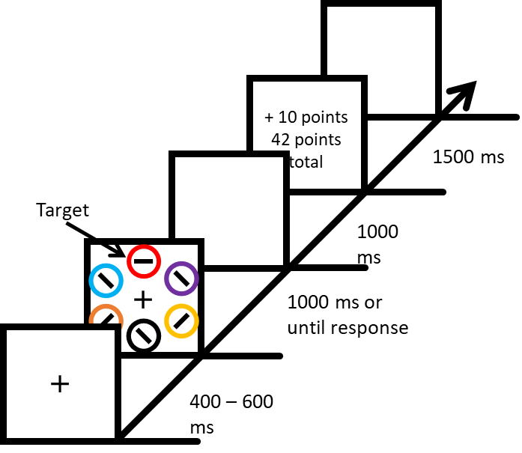

**Figure 2**

*Procedure Used in Transfer Phase*

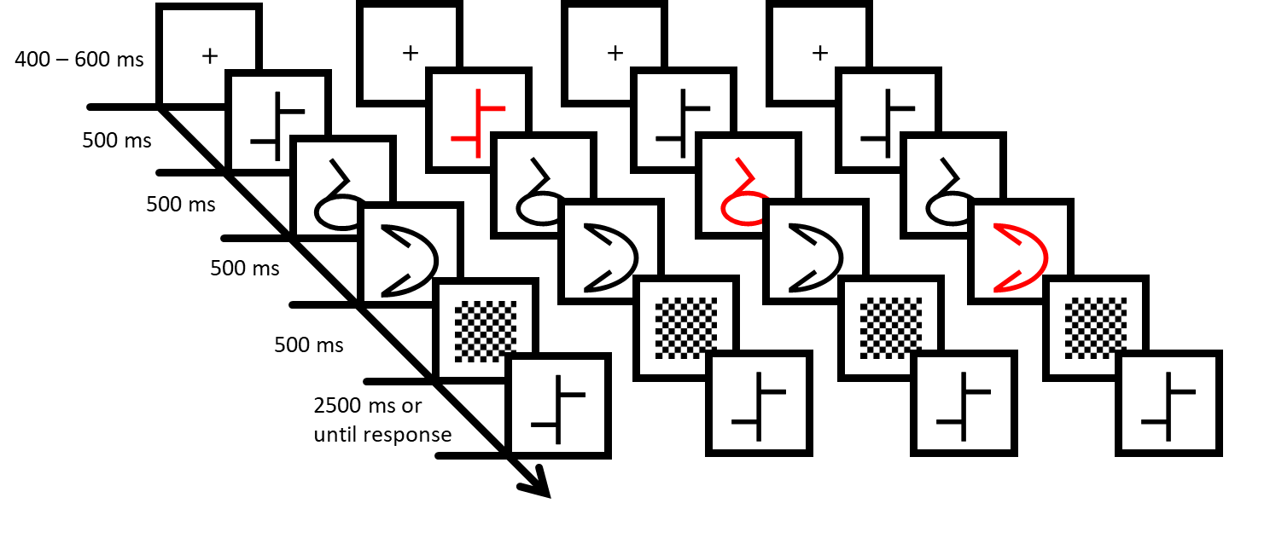

**Figure 3**

*Behavioral Results for Learning Phase*

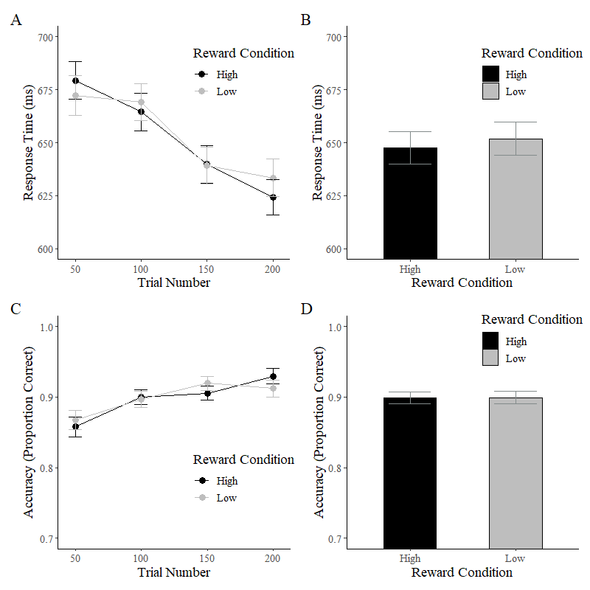

*Note*. (A) Response time by trial block. (B) Response time by reward condition. (C) Accuracy by trial block. (D) Accuracy by reward Condition. Error bars represent standard error of the mean.

**Figure 4**

*Collapsed Behavioral Results for Transfer Phase*

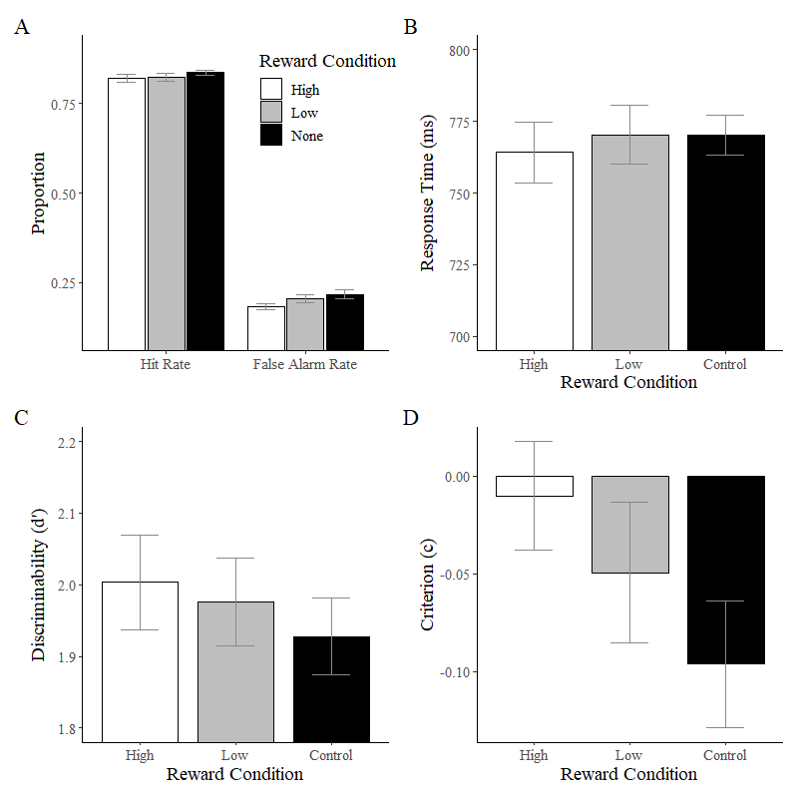

*Note*. (A) Hit rate and false alarm rate of participants by reward condition. (B) Response time by reward condition. (C) Discriminability measured in *d’* by reward condition. (D) Response bias measured in criterion (c) by reward condition. Error bars represent standard error of the mean.

**Figure 5**

*Uncollapsed Behavioral Results for Transfer Phase*

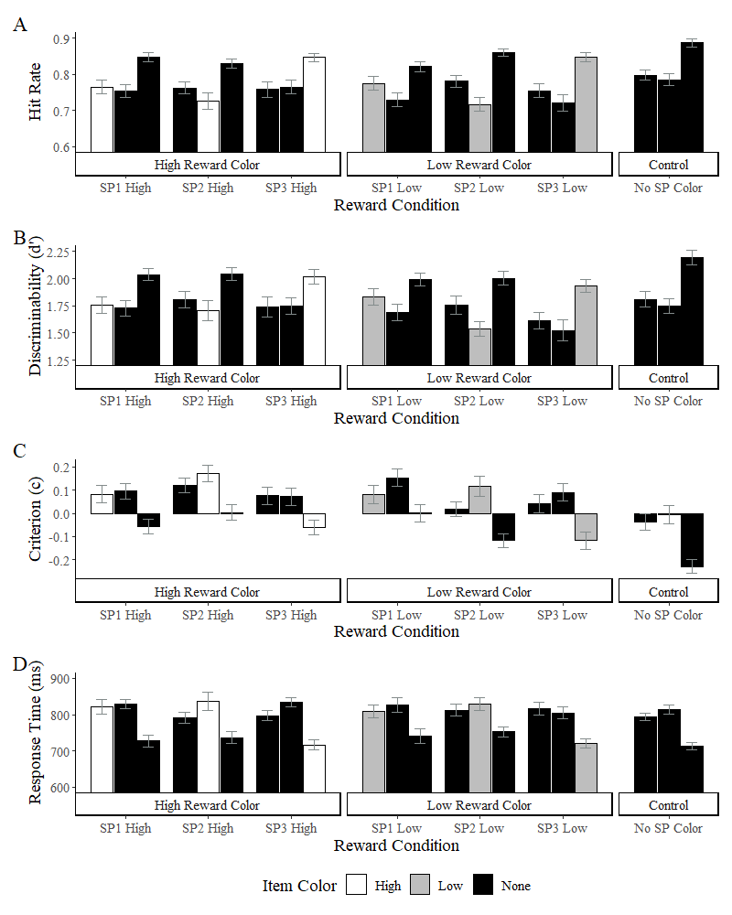

*Note*. (A) Hit rate by target and color item position. (B) Discriminability by target and color item position. (C) Response bias by target and color item position. (D) Response time by target and color item position. Error bars represent standard error of the mean.